Moestopo International Review on Societies, Humanities, and Sciences (MIRSHuS)
http:
ISSN:
TYPE THE TITLE OF YOUR ARTICLE
The First Author*
Affiliates of the First Author (Institution/University)
The Second Author
Affiliates of the Second Author (Institution/University)
The Third Author
Affiliates of the Third Author (Institution/University)

*Correspondence: email address of the first author
ARTICLE INFO |  | ABSTRACT
Article History:  received:  revised:  accepted:  Keywords:  keyword one; keyword two; keyword three; etc. (at least 3 keywords)  DOI: |  | Type the English abstract here. The content of abstract or abstract use font Cambria 10. Abstract consists of: main problem, purpose, method, result, and conclusion. It is written in the form of one paragraph, without reference, acronym, and footnote. It is not written in form of mathematics, question, and assumption. It is not copy paste results of sentences existing in the content of the manuscript. Length of English abstract is 200 words.

INTRODUCTION
The content of introduction is a fundamental issue or urgent issue or background issue of a study/research. It is written in Cambria (font 11).

METHOD
The content of study is a technique of data collection, data resources, the way how to analyze data, correlation test, and so on, it is written in Cambria (font 11). In this chapter, it’s also be listed a scientific formula that can be used as data analysis/correlation test.

RESULT AND DISCUSSION
Content of Result and Discussion
The main discussion contains of result and discussion; it is written in Cambria (font 11). The result is not raw data but the data that have been processed/analyzed by the method set up. The discussion is the result comparison obtained from the concept/theory available in the reference. The content of result and discussion include the statement, table, picture, diagram, graphic, sketches, and so on.

Table and picture are maximum 6 inserted by the names of table and pictures and resources

Table 1. Table Title
No | Aspects | Criteria | Amount
1 | Discipline
2 | Integrity
3 | Attitude
Source:

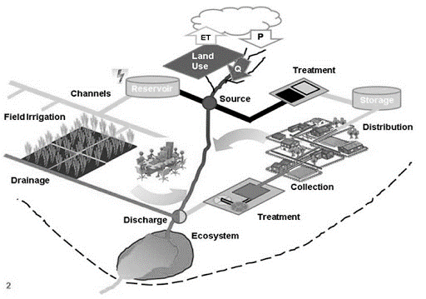
Figure 1. River Basin Management
Source:

Content of Result and Discussion
This part contains sub main discussion written in the font of Cambria 11. Sub-discussion is written systematically. It is expected that no need to write it too much numbering.

CONCLUSION
The content of conclusion is written in Cambria (font 11). The conclusion is an overview of a research that has been done. It does not result summary of discussion which refers to ascertain theory, but the result of analysis/correlation test of the data discussed.

Acknowledgement (if any)
It is optional (if any). It is written in one paragraph by using a font of Cambria 11.

Abbreviation (if any)
It is optional. It is written in one paragraph by using a font of Cambria 11.

REFERENCE
The content of the reference is written with the font of Cambria 11 and 1 space. It is the reference/referral source used as an excerpt from the manuscript. Writing a reference uses the rule of American Psychological Association (APA) 7th Edition. The number of referral resource made as reference are at least 10 titles of scientific literature (80% is a primary reference and 20% is secondary reference). The source of primary references, such as: journal, research report, theses, dissertation and proceeding papers. Secondary reference sources, such as: books and online sources. Writing quotes is recommended It is better to use application of reference manager example Mendeley, endnote, Zotero, etc.

Example of Writing a Reference

Bailey, Garrick, et al. 1999. Introduction to Cultural Anthropology. Belmont, CA: Thomson Wadsworth.
Bambang, Dwiloka dan Rati Riana. 2005. Teknik Menulis Karya Ilmiah. Jakarta: Rineka Cipta.
Day, Robert A., and Barbara Gastel. 2006 (6th Edition). How to Write and Publish a Scientific Paper. Westport, Conn.: Greenwood Press.
Direktorat Jenderal Pendidikan Tinggi. 2014. Pedoman Akreditasi Terbitan Berkala Ilmiah. Jakarta: Ditlitabmas.
Hacioglo, Umit and Hasan Dinser. 2013. Globalization and Governance in the International Political Economy. Istambul, Turki
Hames, Irene. 2007. Peer review and Manuscript Management in Scientific Journal: Guideline for Good Practice. Malden, MA: Oxford: Blackwell Pub.
John D. Campbell, Andrew K.S. Jardine , Joel McGlynn (Editor), 2010. Asset Management Excellence: Optimizing Equipment Life-Cycle Decisions, Second Edition (Dekker Mechanical Engineering), : CRC Press; 2nd edition.
Kay, Kumar. 2006. Evaluating Strategies Used to Incorporate Technology into Pre-service Education: A Review of the Literature. Journal of Research on Technology 38(4), 383-408.
LIPI. 2014. Peraturan Kepala LIPI Nomor 3 tahun 2014 tentang Pedoman Akreditasi Terbitan Berkala Ilmiah. Jakarta.
McLeod Jr,Raymond. 1995. Management Information System a Study of Computer-Based Information Systems. Englewood Cliffs, New Jersey: Prentice-Hall.Inc. Alih Bahasa Hendra Teguh.1996. Sistem Informasi Manajemen. Simon &Schuster (Asia) Pte.Ltd
Rustandy, Tandean. 2006. Tekan Korupsi Bangun Bangsa. (http://www.kpk. go.id/modules/news/article.php?storyid=1291, diakses 14 Januari 2007).
Suwahyono, Nurasih dkk. 2004. Pedoman Penampilan Majalah Ilmiah Indonesia. Jakarta: Pusat Dokumentasi dan Informasi Ilmiah, LIPI.
Where to Get Mendeley. From the Web: http//www.mendeley.com/download-desktop/switchedFrom

